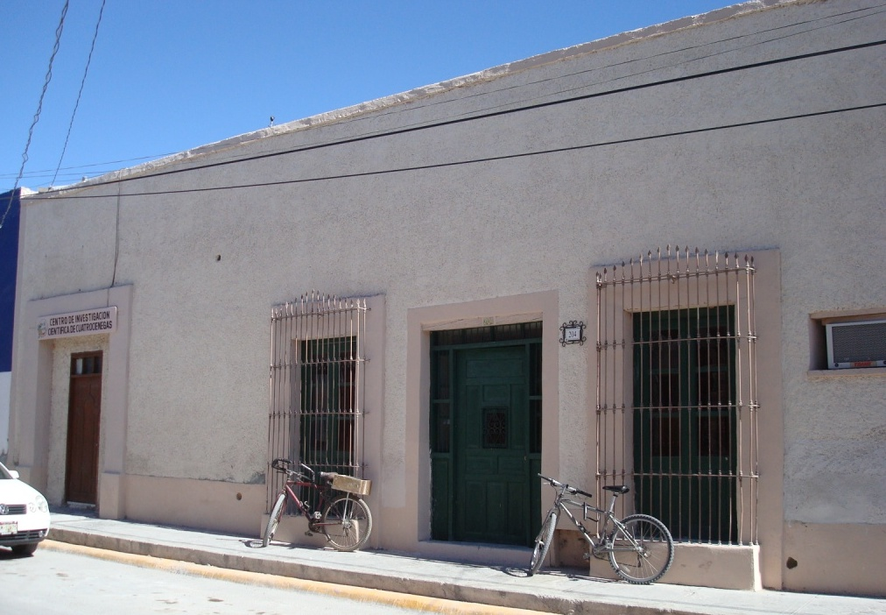
This is a picture of the outside of CICC, 204 Presidente Carranza, right next door to Desuvalle. The CICC office is the brown door on the left with a sign above it, the house is the green door on the right.

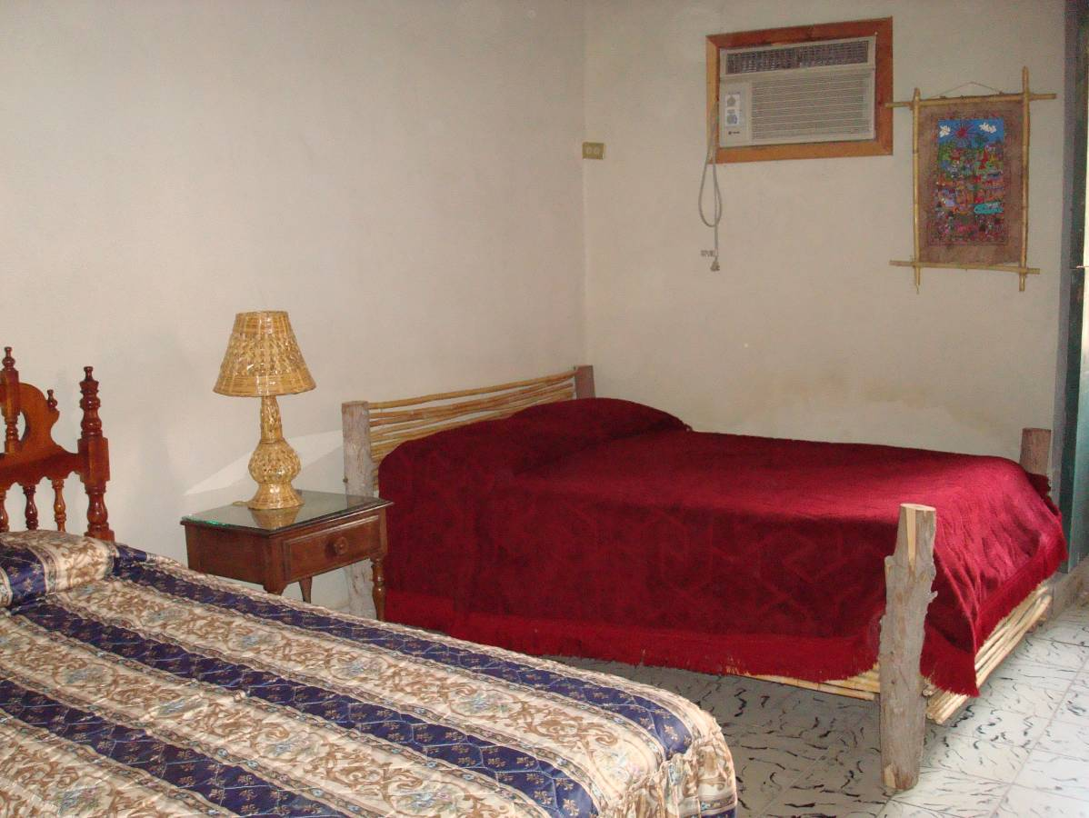Bedroom #1- 1 double bed, 1 twin bed, can sleep up to 3 people.

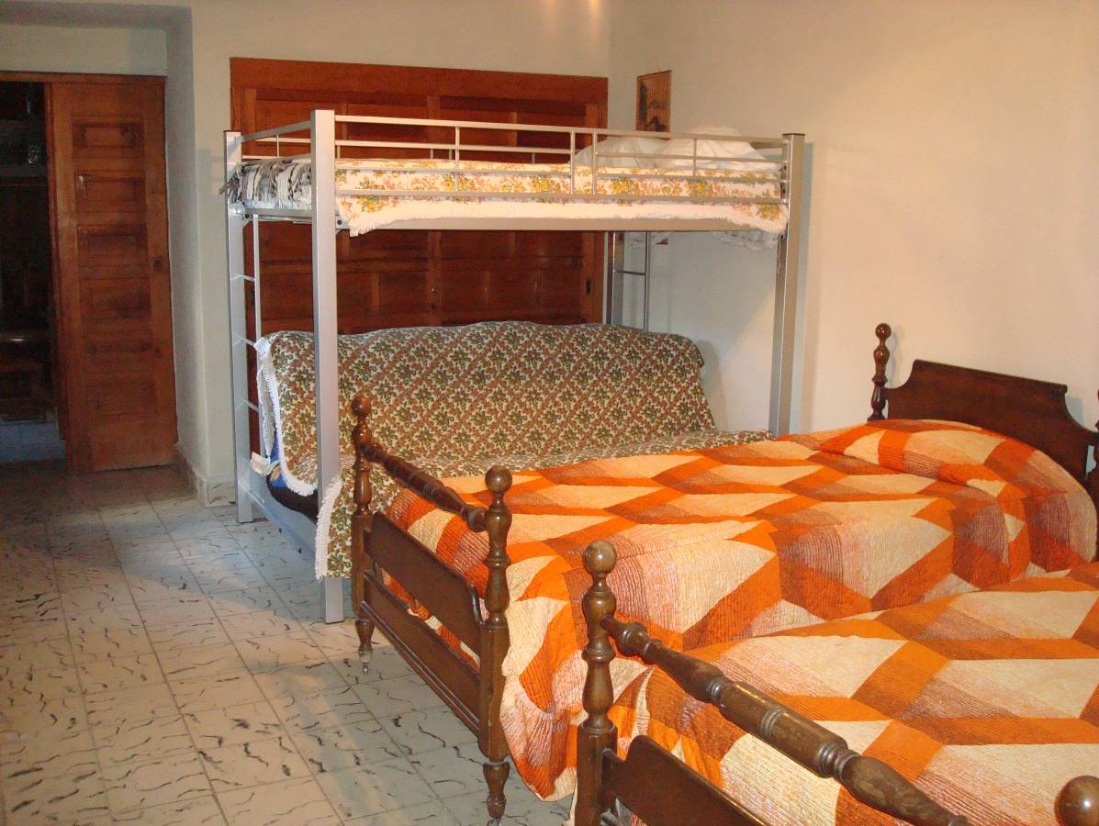
Bedroom #2- 2 double beds, 2 twin beds, can sleep up to 6 people.

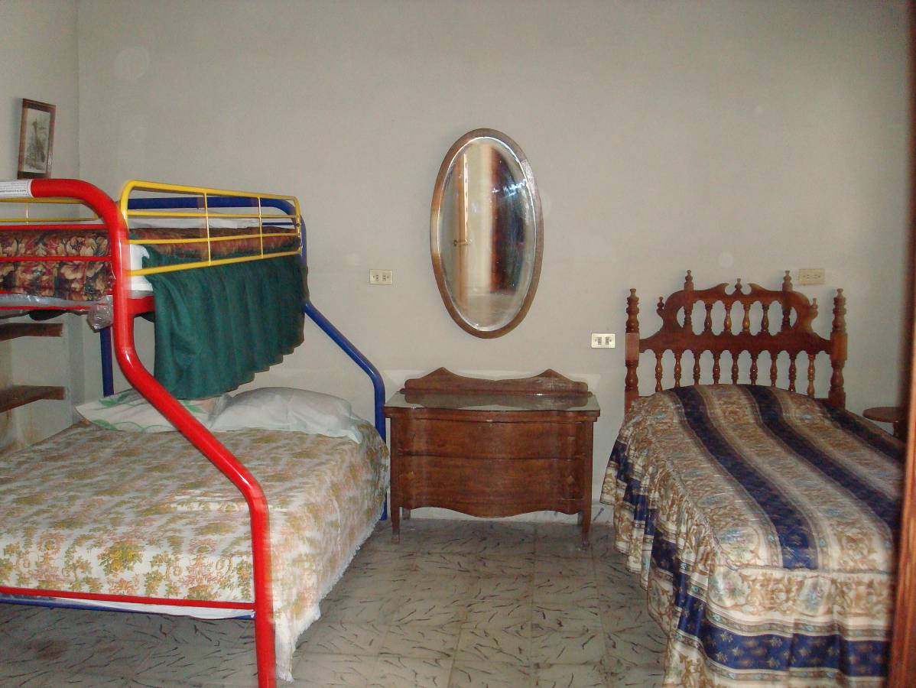Bedroom #3- 1 double, 2 twin beds, can sleep up to 4 people.

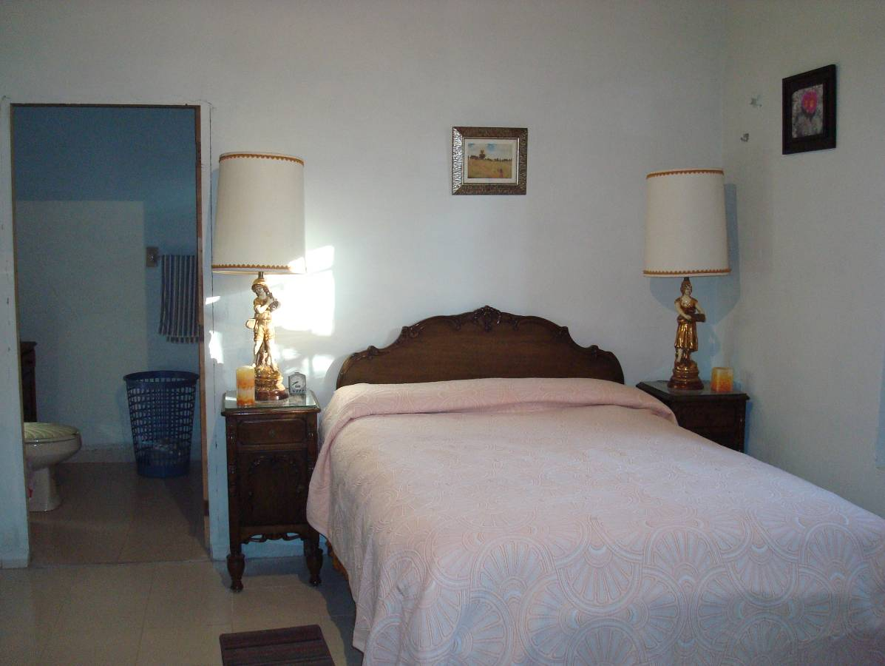

Bedroom #4- Manager’s bedroom with private bathroom.
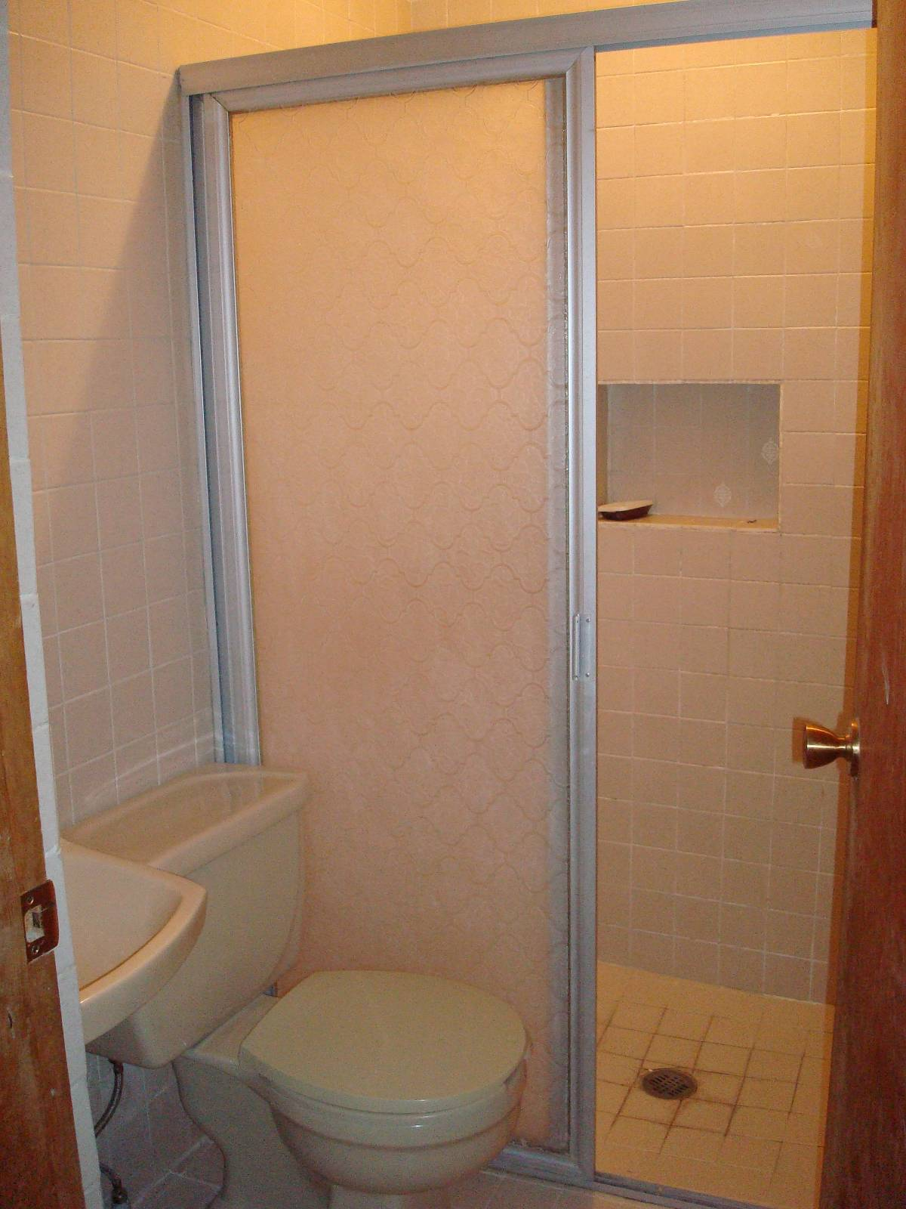
Full community bathroom between bedrooms #1 and #2

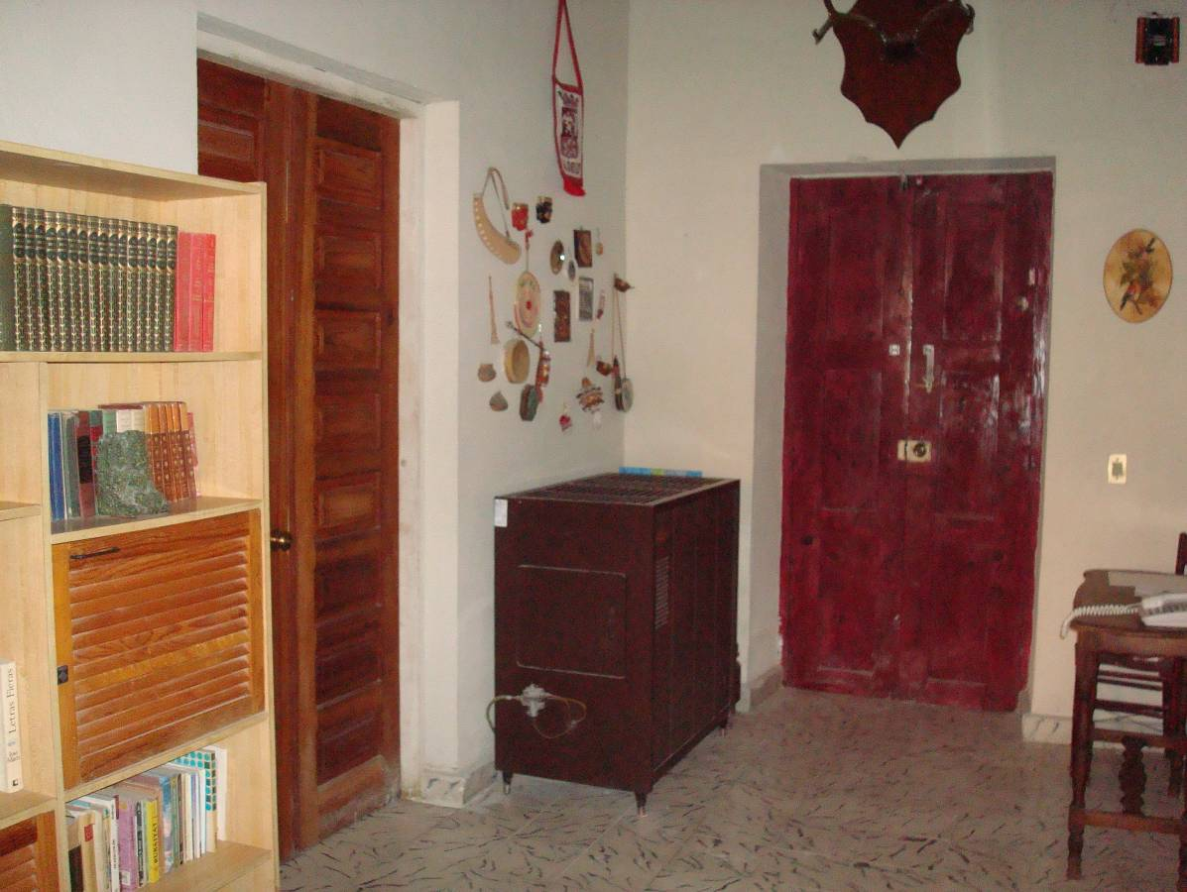
This is the hallway view from the living room/house entrance. The community library bookshelf is on the left and the phone station is on the right.

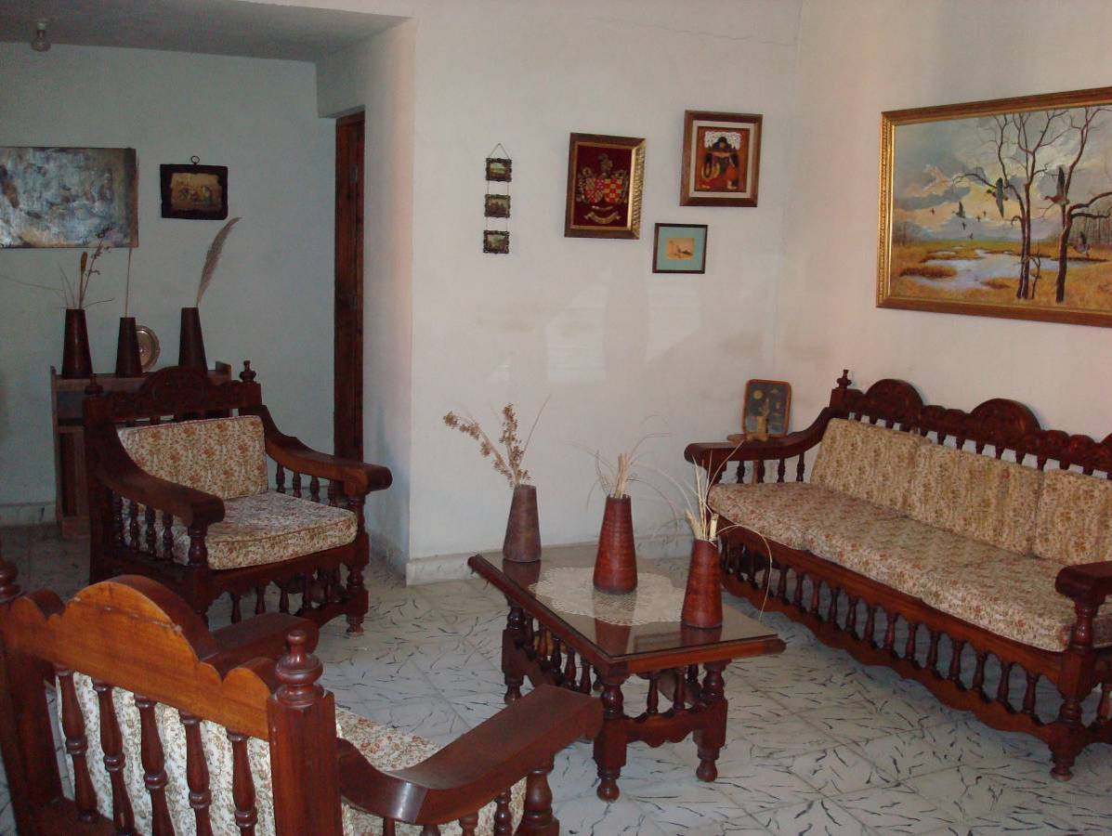

Front living room area with a half bathroom (picture below). To the left, not shown in photo, there is a community desk work space with access to wireless internet.

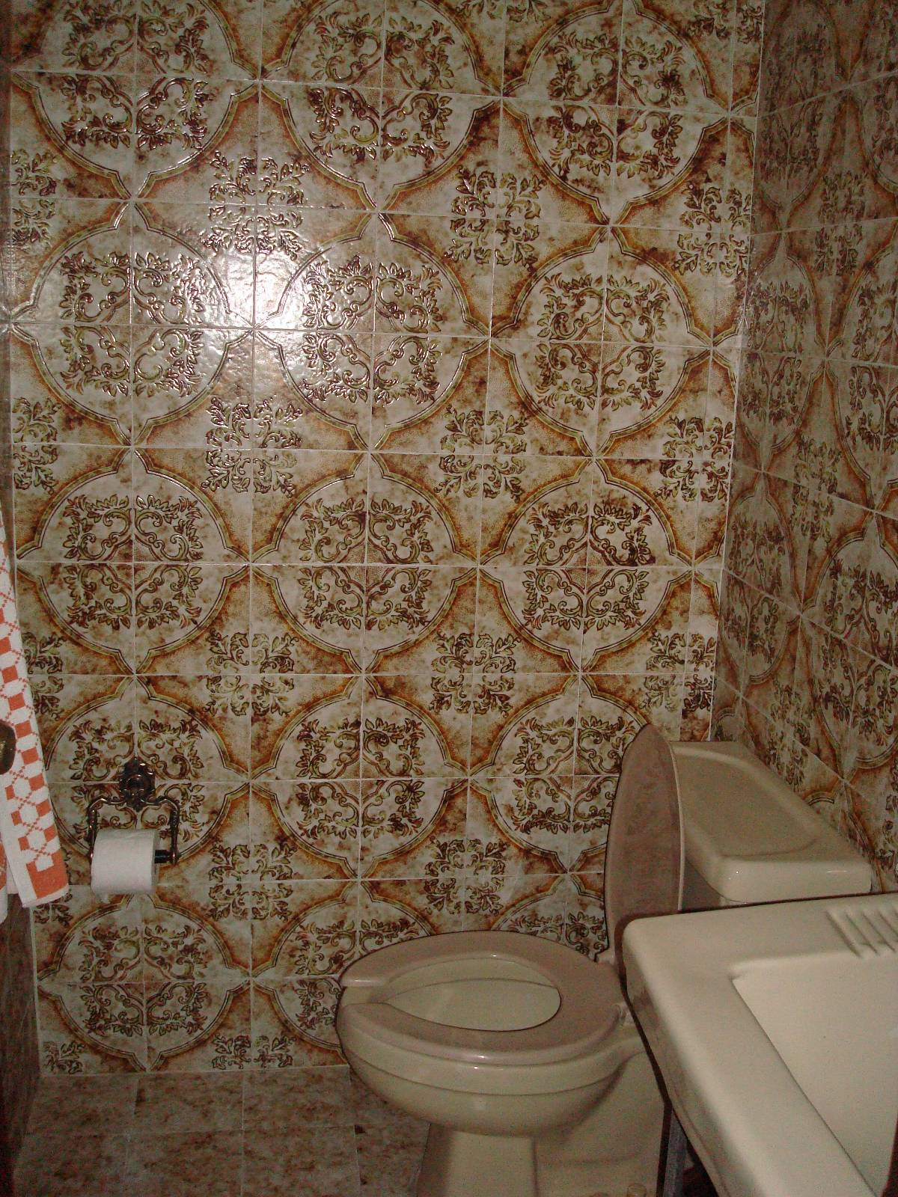
Half bathroom located off of living room.

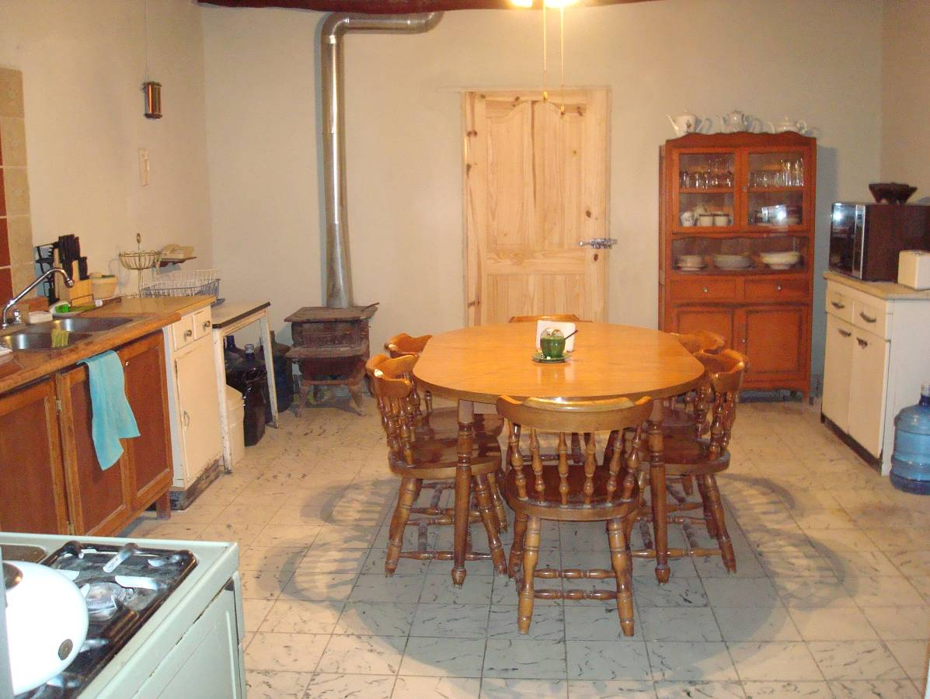
Large, fully equipped kitchen with access to backyard.

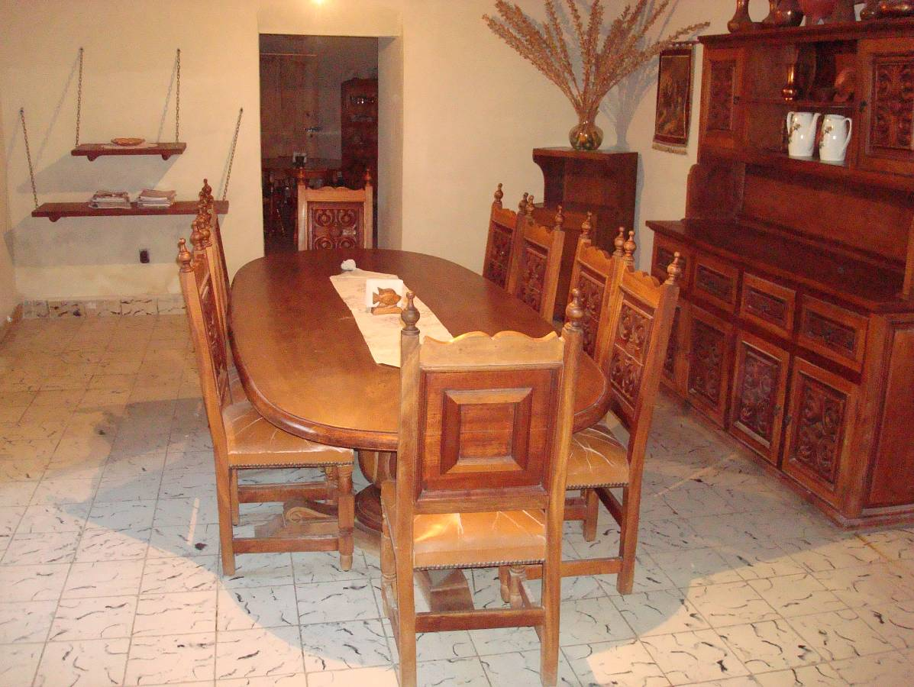
Large dining room /meeting area just outside the kitchen.

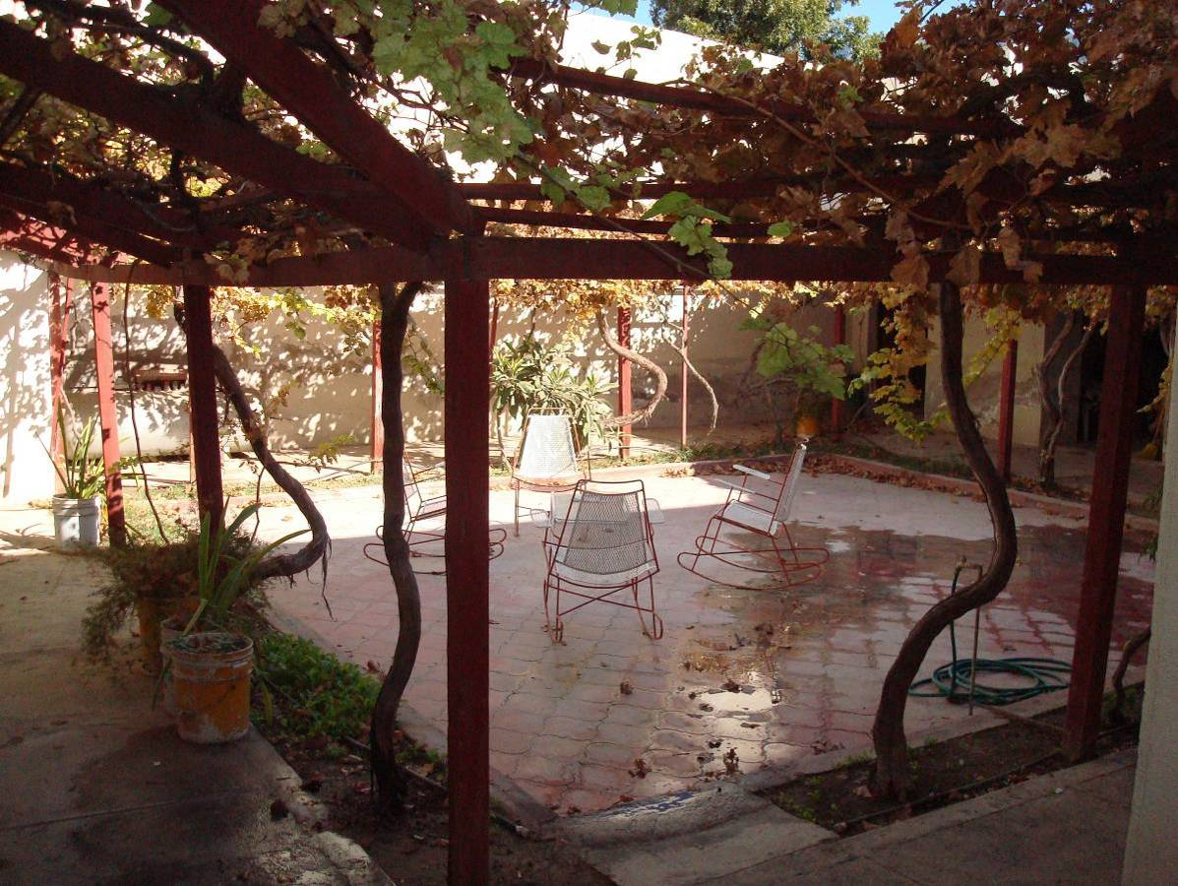

Here’s a view of the cute front patio, totally enclosed and private.

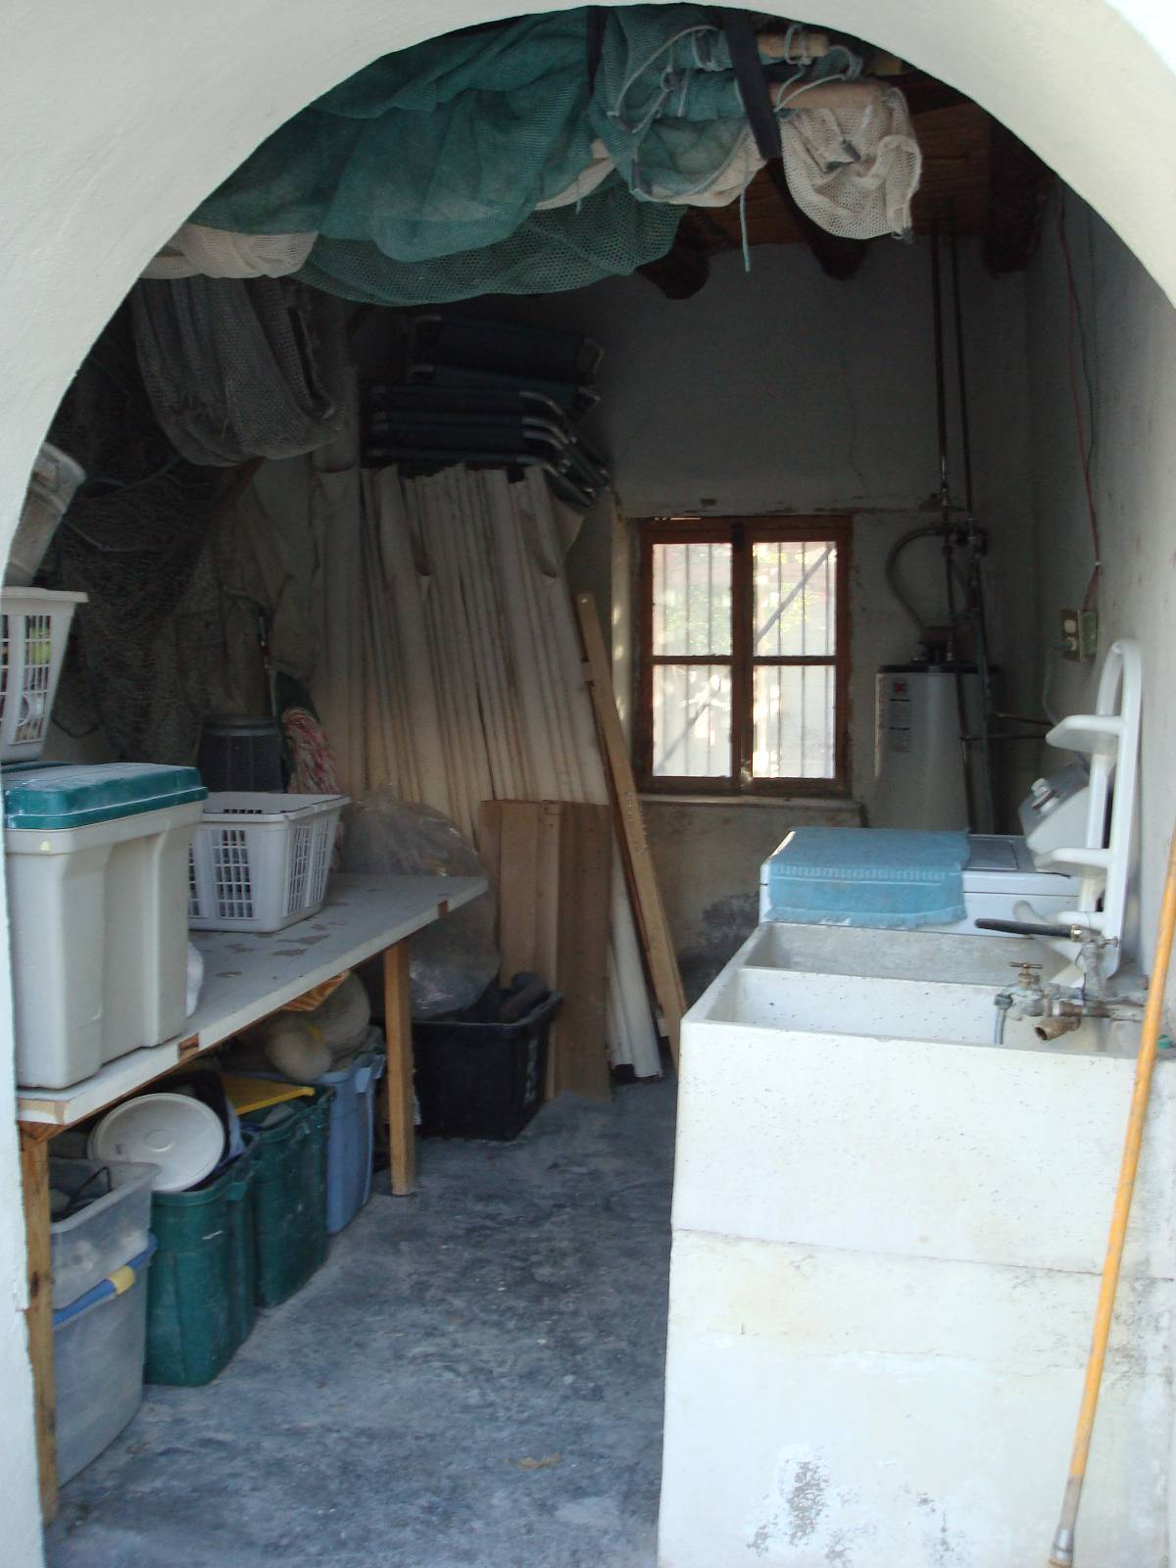
Laundry/ storage area off of front patio.
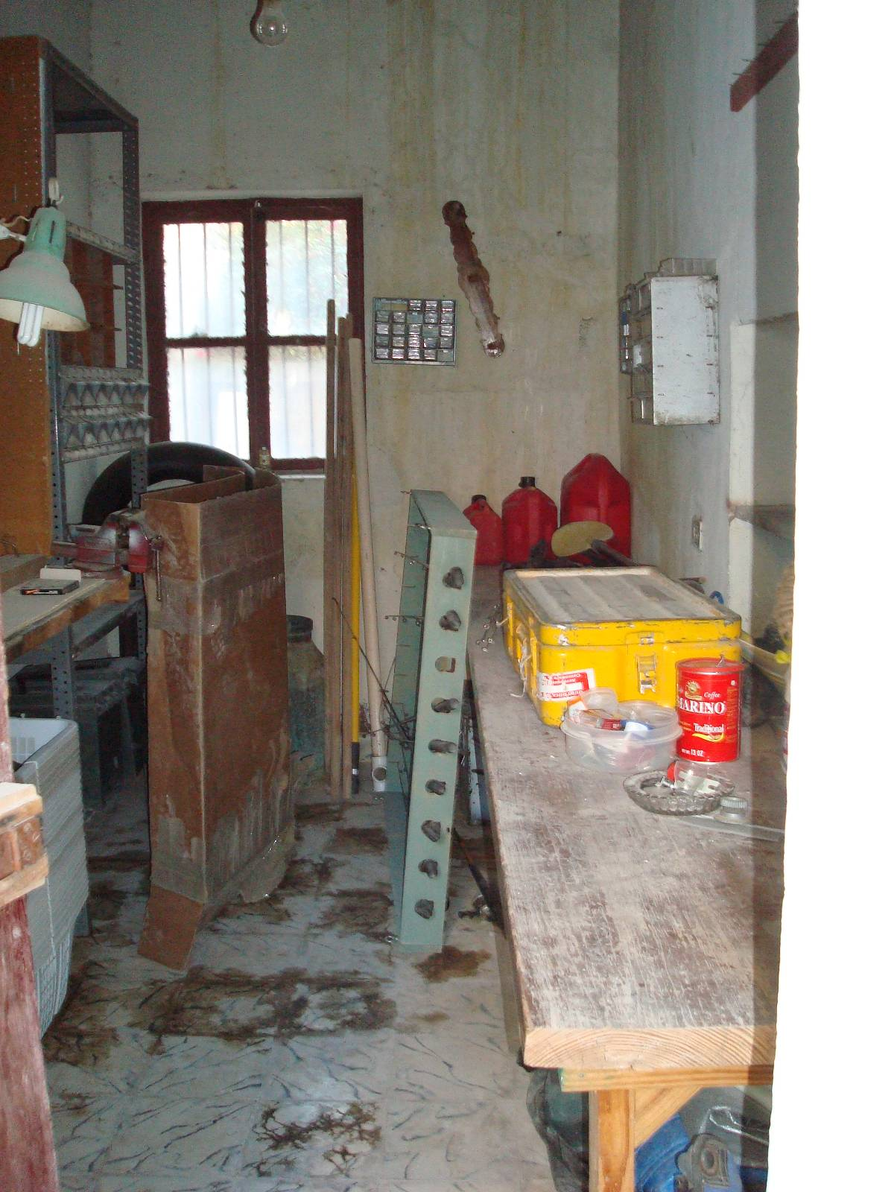
Workshop/storage area off of front patio.

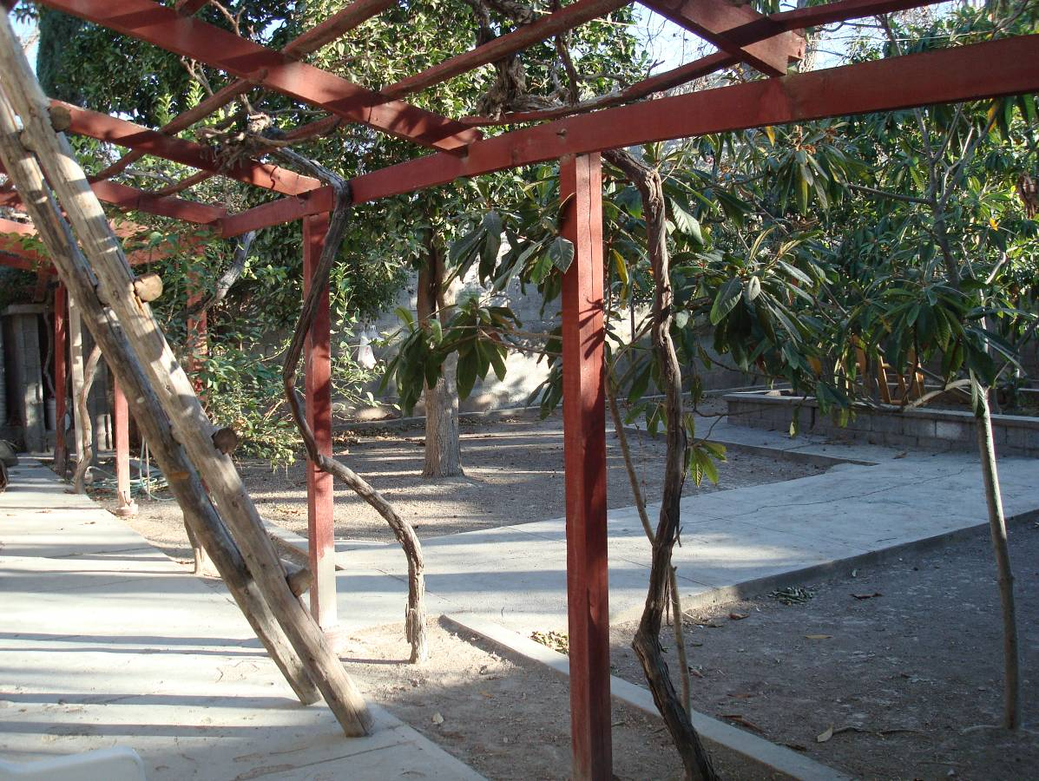
Back porch of house.
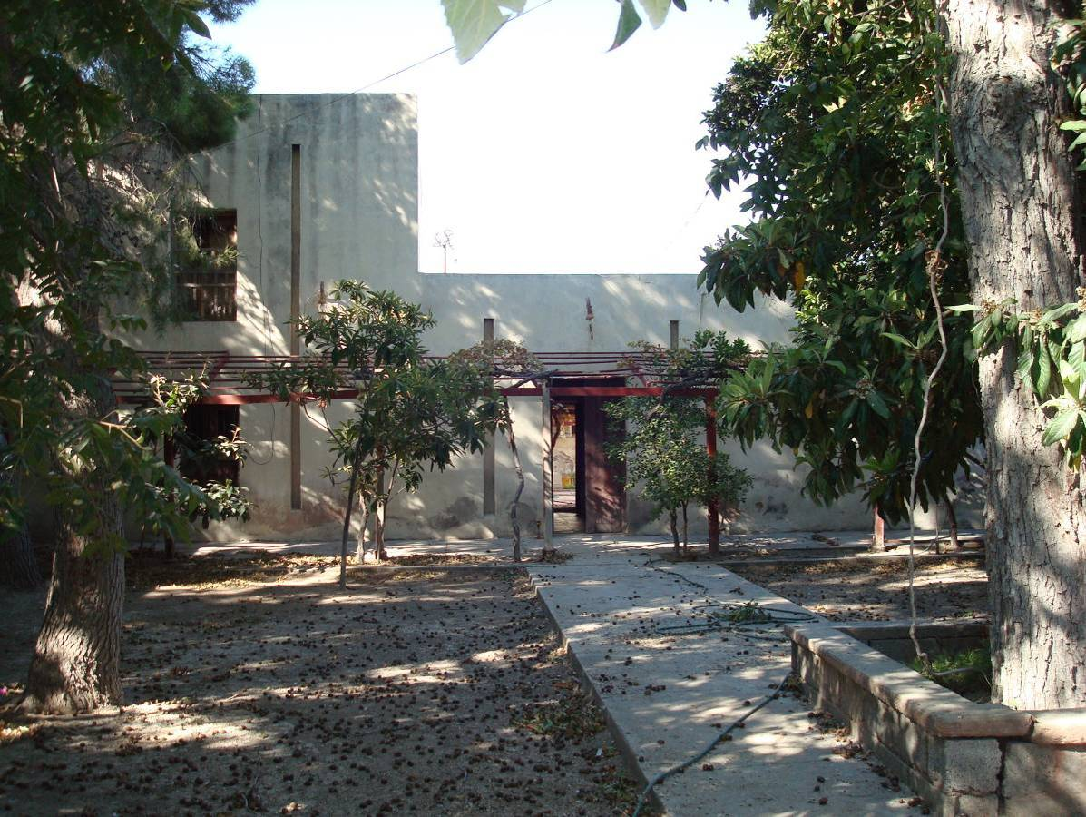
Huge, shaded backyard (looking back toward house), plenty of room for camping.

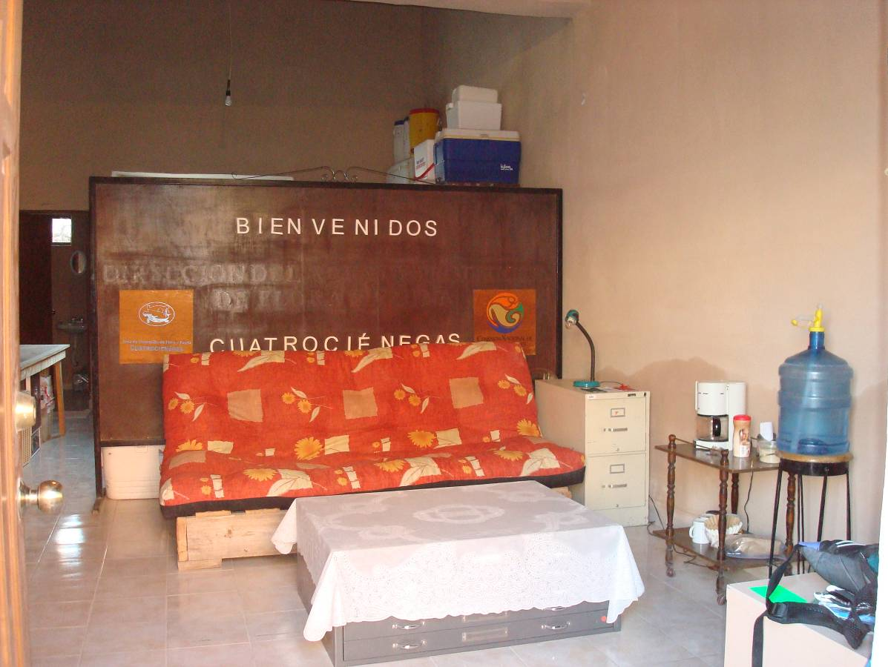Office waiting room/meeting area, located right next door to the house. The equipment/storage area is located behind the room separator. The office has its own half bathroom, and the sofa can be used as bed if necessary.

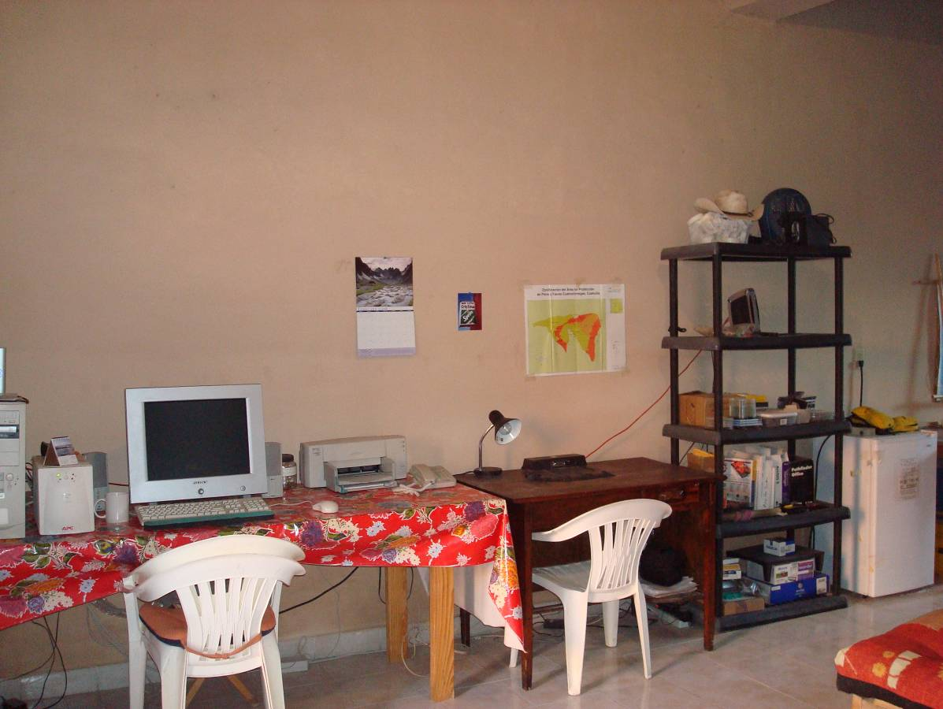Office computer and desk space.

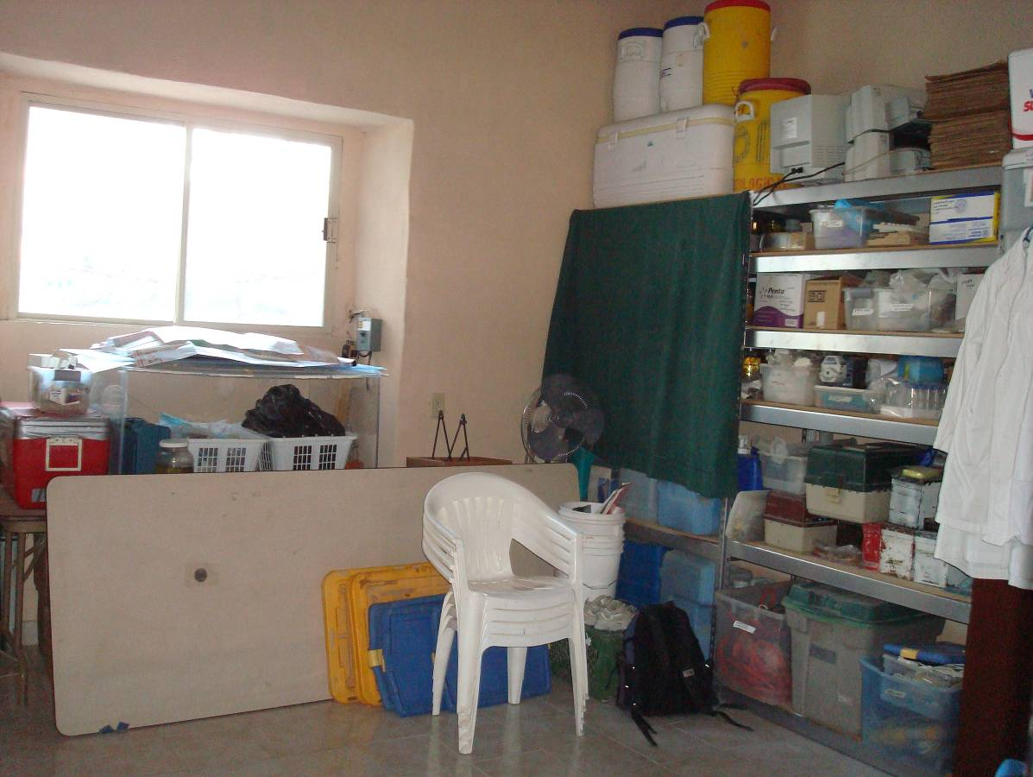
Laboratory/ equipment storage area in back of office.

