Arundo Eradication Plan: Cuatro Ciénegas, Coahuila, Mexico
Initially prepared by:
Suzanne McGaugh, Iowa State University, EEOB
Dean Hendrickson, University of Texas-Austin, Texas Memorial Museum
Gary Bell, The Nature Conservancy, New Mexico, Conservation Science
Valeria Souza, Instituto de Ecología de la UNAM
Lucas McEachron, Florida State University,
Kelly Lyons, Trinity University, Department of Biology

With participation of persons attending the Taller sobre de Arundo sponsored by The Nature Conservancy and Pronatura, including representatives from Desuvalle, A.C., Universidad Iberoamericana, Instituto de Ecología de la UNAM (IE/UNAM), CONANP, University of Texas, Iowa State University, Florida State University, the community of Cuatro Ciénegas, PRONATURA-Noreste, and The Nature Conservancy.

Program Information
Recently, wetlands and rivers in Cuatro Ciénegas, Coahuila, Mexico have become infested with an alien weed species known as giant reed (Arundo donax). Public and private agencies with ownership and/or management responsibilities share a common concern in dealing with the immediate threats of excessive transpiration of water, wild fires, and loss of habitat that are commonly associated with this species.

The focus of this management plan is the eradication and long-term management of giant reed in the Cuatro Ciénegas Natural Protected Area. Secondary objectives include revegetation of key areas where aesthetics and/or lack of recovery by native vegetation requires habitat enhancement.

Background
The valley of Cuatro Ciénegas, in Coahuila, México, is ranked among the world’s most unique ecosystems. Harboring over 70 endemic species, its endemism is higher than any other place in North America (Stein et al. 2000). Much of the valley’s biotic diversity is associated with a diverse complex of hundreds of geothermal springs, lakes and streams that exhibit extreme temperature and water chemistry variation often over very small spatial scales. Many of the species are classified as endangered or threatened by the Mexican government and the Convention on International Trade of Endangered Species (CITES). This extreme fragility of the ecosystem resulted in it being declared a National Protected Area (Secretaria de Desarrollo Social 1994). However, continued threats to biodiversity include water exploitation, exotic species’ invasions, industrial development, and rapidly increasing tourism and population growth.
At the recent Cuatro Ciénegas researcher's meeting, ‘Congreso de Investigadores de Cuatro Ciénegas, direct conservation concerns to the valley were addressed, and the growing invasion of Arundo donax, the giant reed, climbed near the top of this list. In addition, in the reexamination of invasive species by Programa de especies invasoras de México, organized by Conocimiento y uso de la Biodiversidad (CONABIO), A. donax became one of the top threats. This bamboo-like, perennial grass is a notoriously aggressive threat to warm freshwater ecosystems (Polunin and Huxley 1987). Establishing by rhizomes, it spreads clonally and quickly displaces native vegetation (Khudamrongswat et al. 2004). Arundo donax is placed among the fastest growing terrestrial plants (nearly 10 cm/ day (Dudley 2000)), and, per unit of biomass, it is reported to use three times more water than native vegetation (Else 1996). These properties set the stage for substantial modification of physical and chemical characteristics of an ecosystem including accelerating fire cycles and deterring flood prevention (i.e. Bell 1997; Dudley 2000). Currently, management authorities in the United States are spending large amounts of money attempting to control invasions in California (Dudley 2000). Fortunately for land managers, the seeds produced by Arundo in California are seldom, if ever, fertile. Likewise, by inspection of the seed and genotypes this appears to be the case in Cuatro Ciénegas as well (Lyons pers comm., Eguiarte et al. presentation 2005). As such, spread, and therefore management, of giant reed is essentially an intra-basin and downstream phenomenon.

These aspects led the The Nature Conservancy and Pronatura Noreste to sponsor the Arundo Control Symposium in Cuatro Ciénegas during June 2005. At the forum representatives from the community of Cuatro Ciénegas, four agencies, and five universities addressed steps needed for eradication. Experts agreed that currently, the invasion is manageable. However, due to the aggressive nature of this plant, the consortium emphasized that immediate action is necessary to minimize the cost and ecosystem impact incurred by eradication and control. The following goals were set:

- Conduct experiments investigating impact of herbicide on the stromatolites.

- Develop an operating plan of action and costs, detailing application procedures, the spatial sequence of application, mechanisms to reduce re-invasions, and subsequent monitoring.

- Enact a public awareness campaign on the negative impacts of the Arundo.

Remediation techniques
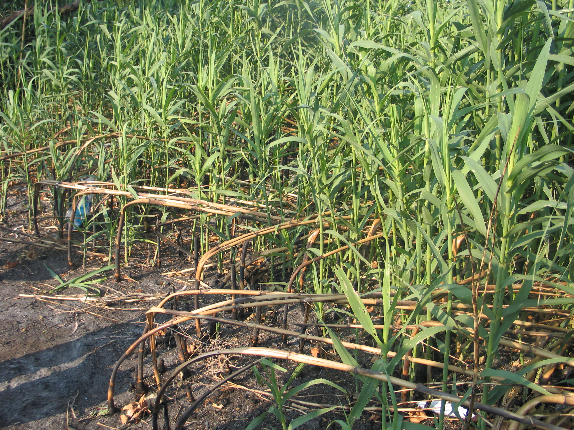
In California, a great effort (money and time) has been spent in developing effective procedures for Arundo removal. Management techniques such as manual and mechanical removal and fire, implemented in the Santa Ana and Santa Margarita and River basins, have proven sub-optimal (Bell 1993, 1997). Manual or mechanical removal often results in dispersal of plant propagules , including rhizome fragments and stem nodes. Root masses can be missed and/or left behind, removal of the biomass can spread the invasion, and equipment used for physical extraction can spread the plant through fragments being caught in the machinery. In addition to these downfalls, manual eradication and removal of biomass is expensive. The price tag for only the above ground biomass cutting (not including removal from the site) is $5000USD per acre (Bell 1993).

Fig. 1. Arundo donax approximately two weeks post burn along the Ocampo Road, in Cuatro Ciénegas, Coahuila, Mexico.
Fire, by itself, likewise is not a solution. Arundo regenerates quickly after fire (see Fig 1.) and rapidly outgrows any native species that may have otherwise taken root in a burned-over site. Fire events, thus, tend to push wetland communities to monocultures of giant reed with little or no additional plant species diversity, of Arundo donax (Bell 1993).
Treatment of Arundo with a wetland-approved herbicide containing glyphosate has provided direct, effective control of the plant without high risk of reinfestation or dispersal of the biomass, and thus the invasion (Bell 1997). In addition, glyphosate is appropriate for environmentally sensitive areas because its bioavailability is diminished quickly after application. Although this method is putatively the most flexible and efficient, and has been widely accepted elsewhere, application of herbicide will still be approached with caution.

Herbicide trial
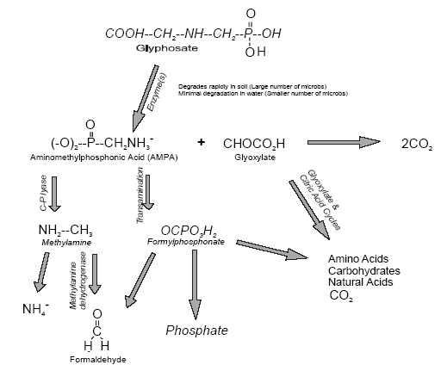
Although glyphosate was declared by the United States Environmental Protection Agency (1993) to “not pose unreasonable risks or adverse effects to humans or the environment,” prudence when applying herbicides is necessary in this fragile ecosystem for three main reasons. First, Cuatro Ciénegas’ ecosystem is adapted to low nutrient levels and excess phosphorus and other resources have been shown to be detrimental to invertebrates. Secondly, Due to the low resource content and high salinity, cyanobacteria complexes have precipitated calcium carbonate, forming stromatolites. These complexes provide the basal strata of the food chain in some localities within the basin, but also are extremely rare in their living form (EPA 2001). In areas such as the Shark Bay World Heritage Property in western Australia, the stromatolites take the highest conservation priority (EPA 2001). In addition, cyanobacteria are the basic structure from which chloroplasts (the photosynthesis center of the plant cell) are derived evolutionarily. The possibility that these organisms contain the same molecular pathway, which is attacked by glyphosate, must be addressed and investigated. Lastly, public safety concerns circulate around the use of herbicides.
Fig 2. Taken from Schulette 1998
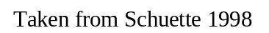

Molecular pathway of the herbicide
Glyphosate, the active ingredient in Rodeo®, is a non-selective, post-emergence herbicide that is easily transported by the phloem throughout the plant (Franz et al., 1997). Glyphosate is absorbed through the leaf into the plant cells where it is transported to meristematic tissues (Laerke, 1995). Once taken up by the plant, glyphosate inhibits the activity of a chloroplast-localized enzyme, 5-enolpyruvylshikimate-3-phosphate synthase (EPSPS), found in the shikimic acid pathway of plants (DellaCioppa et al., 1986). The creation of chorismate is then halted. Subsequently, aromatic amino acids are not produced and protein synthesis is terminated (Franz et al., 1997). Visibly, wilting and discoloring of the plant will occur in 4-14 days. Since glyphosate fits into and disables the protein synthesis pathway, it acts more slowly that some typical herbicides. However, this property allows it to be utilized and degraded by microbes and be bound up in soil particles (Franz et al. 1997).

Environmental safety
Aerial volatilization is not a fate for glyphosate (Franz et al. 1997). Though, aerial drift may cause damage to non-target plants, this problem is minimized when wind velocities are low (Schulette 1998).
In aquatic systems, glyphosate is very soluble (11,600 ppm at 25 OC Kollman and Segawa, 1995) having an octanol-water coefficient (logKow) of -3.3. Glyphosate is stable in water at pH 3, 5, 6, and 9 at 35 °C and it is stable to photodegradation in pH 5, 7 and 9 solutions under natural sunlight (as specified by US EPA’s reregistration eligibility decision (RED) 1993). Studies indicate that hydrolytic decomposition is low, and microbial activity and sediment absorption is mainly responsible for degradation seen (Bronstad and Friestad 1985, Kirkwood 1979, Ghassemi et al. 1981). Confirming this in forest ecosystems, Schulette (1998) reviewed the decomposition of glyphosate waterways high in suspended sediment. For ponds and streams, first-order half-lives were found to be 1.5-11.2 days and glyphosate was undetectable in 3-14 days, respectively. For all aquatic systems, sediment appears to be the major sink for glyphosate residue.
In soil, glyphosate is resistant to chemical and sunlight degradation, substantially nonleachable, and has a low propensity to runoff (apart from being adsorbed in colloidal matter (Schulette 1998). Likewise, soil glyphosate tenacity is low. Half-lives range from 3 to 130 days (U.S. EPA 1990; USDA 1984), with soil field dissipation half-lives averaging 44-60 days (Kollman and Segawa 1995; WSSA 1989). The degree of soil binding depends on availability of unoccupied phosphate binding sites (Sprankle et al. 1975). Therefore, soil phosphate level is the main factor determining soil absorption, because of competition with inorganic phosphate (Sprankle et al. 1975). Microbes are mainly responsible for decomposition. So, the rate of the degradation is dependent on the composition of the microbial fauna (both aerobic and anaerobic) and the soil factors that affect their activity (Eriksson, 1975). 14C-labeled glyphosate studies indicate that 55% of the herbicide was metabolized and converted to 14CO2 within 4 weeks in sandy, loam soil (USDA, 1984; Rueppel et al., 1977). Although, inactivation and decomposition are completed by microbes, Stratton and Stewart (1992) concluded that glyphosate has no significant effect on the numbers or respiration rate of bacteria, fungi or actinomycetes in forest soil and overlying forest litter. Furthermore, nitrogen fixation, nitrification and denitrification activity are not adversely affected by the application of glyphosate (Muller et al. 1981). Lastly, glyphosate supports quick regrowth, because it shows no pre-emergent activity even when applied at high rates (Franz et al. 1997). For example, less than one percent of the glyphosate in the soil was found to be absorbed via the roots of new plants (Ghassemi et al. 1981).

Public and wildlife safety

High water and low fat solubility of glyphosate indicates its low bioaccumulation potential. Support for this hypothesis includes excretion of 97.5% of the administered dose in rats, and additional investigations follow the same trend in other mammals, birds, and fish (Franz et al., 1997). Li and Kole (2004) enforced sublethal (nearly lethal) exposure levels on the topmouth gudgeon, Pseudorasobora parva and measured gill ATPase and liver esterase activity at 8th, 16th, 24th and 65th days of exposure. Although an inhibiting effect occurred, recovery appeared with time. Similarly, oral dose experiments performed by the U.S. EPA’s RED display that glyphosate is nearly non-toxic to upland birds, slightly toxic to waterfowl, and slightly to non-toxic to warm and cold water fish. Chronic exposure in mammals results in no cellular changes and no increased cancer risk (U.S. Department of Agriculture 1981, EPA 1988). Henry et al (1994) rejected that Rodeo® (applied as a tank mixture with X-77 Spreader® and Chem-Trol® abbreviated RTM) creates an acute danger to native aquatic invertebrates. They argued that acutely toxic RTM concentrations surpassed expected or measured amounts in water from wetlands treated with the RTM.

Suspected stromatolite safety
Studies have shown interesting results of glyphosate on cyanobacteria, the main component of stromatolites. For example, Shikha et al. (2004) assayed chlorophyll content and alkaline phosphatase activity in phosphorus starved and phosphorus plentiful photoautotrophic cyanobacteria, A. doliolum. Chlorophyll increased when cyanobacteria were exposed to glyphosate and then supplemented with Pi and a declined when they were Pi-starved. Alkaline phosphatase activity enhanced in response to addition of glyphosate (40 microg/ml), but the activity remained unaltered by addition of glyphosate in the Pi-starved treatment. The results suggested that cyanobacteria may be sensitive to glyphosate in the absence of phosphate and that there exists a glyphosate-induced depletion in the phosphate content of the cells, as evident from the stimulated activity of alkaline phosphatase. However, alkaline phosphatase activity in the Pi-starved bacteria may not be impacted by glyphosate, because the cellular phosphate reserve may be unavailable for further reduction.
Toxicity to cyanobacteria and algae depends on the species or strain (World Health Organization 1994). Wängberg & Blanck (1988) exposed 16 species in pure cultures to Roundup for 14 days. For the most sensitive species growth was inhibited completely with 16 mg Roundup/liter for Raphidonema longiseta and Anabaena sp. and 131 mg Roundup/liter for the least sensitive species (Selenastrum capricornutum) (World Health Organization 1994).
In Pseudomonas chlororaphis, Roundup® inhibited respiration at concentrations of > 2623 mg/liter, but in Aeromonas hydrophila respiration was only slightly affected at these concentrations (Chan & Leung, 1986). Exposure duration was six days.
It is extremely important to note that Rodeo® does not control submerged vegetation or other organisms, and this is likely the case with stromatolites. The bacteria will not be exposed to direct applications or inflated concentrations like the conditions used in these studies. In addition, exposure times were vastly exaggerated during these experiments as compared to actual durations that may be experienced during treatment of Arundo. Furthermore, some of the experiments were performed with Roundup® which contains different surfactants, which could actually be the cause of toxicity (Henry et al. 1994). This in mind, Roundup® is not approved for wetland use and will not be used in Cuatro Ciénegas.

Herbicide experimental protocol

Experimental plots will be established by IE/UNAM in different sites in Rio Mesquites, Saca Salada canal, as well as in the agricultural canals. In each site, a control and an experimental “plot” will be established with 3 replicas. In the experimental plot, Rodeo® will be sprayed as indicated while in the control plot the dilution base (water) will be sprayed to the plants.
At time 0 (before the application) a water (5 liters), a sediment (10 grams) and a stromatolite (10 grams) sample will be taken in each replica from the control and the treated areas. DNA will be extracted from this sample and analyzed with TRFLP of the 16S ribosomal DNA gene. Functional experiments will be performed in parallel at time 0 and 1. This will consist in measure the nitrogen fixation in situ of the stromatolites before and after the Rodeo® application. This sampling will be repeated a week later in all the sampling sites. If the changes in the microbial community are significant in the treatment are another sampling will be needed 6 months after the application to check for recovery of the ecosystem. As parallel work, in vitro experiments will be perform with different doses of Rodeo® in local cyanobacteria that are under axenic culture in the Molecular and Experimental Evolution laboratory at IE/UNAM, Mexico.
Most likely, any impact seen will be temporary or nonexistent. Experimental results should be carefully interpreted in light of the eventual impact of Arundo on this ecosystem. The extreme water depletion, shading, invariable nutrient flow changes, and fire hazards associated with the inevitable wider establishment of this plant will invariably be anything but favorable to Cuatro Ciénegas ecosystem persistence. The protection of the valley from these detrimental aspects is the ultimate goal of Arundo eradiaction and may require toleration of slight, transitory effects.

Eradication
If the herbicide is shown not to exert any long-term adverse effects on the ecosystem Rodeo® will be used to eradicate the remaining stands with the main goals to:
    - Remove and keep riparian areas clear of giant reed near infrastructure and key habitat areas.

    - Be prepared to take advantage of wildfires that clear stretches of the river of stands of giant reed, and herbicide can then be applied to regenerating stalks.

Application
Through the efforts of Californian workers, we have learned that herbicides are most effective when applied in the post-flowering stage, when the plant is sequestering nutrients to the rhizomes (Bell 1997, DowAgrosciences, 2002). Using the plants own translocation system, less herbicide is necessary and the rhizomes are targeted. Therefore, application rates are critical as an overdose may kill the parts of the plant first contacted by the herbicide, and prevent further absorption and translocation (carried along with other nutrients to other parts of the plant after absorption).
Needless to say, application procedures outlined by Dow Chemical Company for Rodeo® will always be followed (see DowAgrosciences Specimen Label for instructions http://www.cdms.net/manuf/mprod.asp?mp=11&lc=0&ms=3691&manuf=11).
Important points for consideration in treatment include:
- There is no restriction on the use of treated water for irrigation or recreational purposes
- To treat areas upstream or within ½ mile of potable water intake, the water intake must be turned off for at least 48 hours. If the glyphosate level is under 0.7 parts per million (determined by laboratory analysis) the water intake may be turned back on.
- Workers should wear gloves, long sleeves, pants, shoes, and socks.
- Always use a heavier dose when the vegetation is dense.
- For Giant Reed 1.5%- 2% solution should be applied in late summer to early fall with hand held equipment.
- Heavy rainfall 6 hours after use will reduce efficiency, heavy rainfall 2 hours after application will require reapplication.
- Extremely cool or cloudy weather following treatment may slow activity of glyphosate and delay development of visual symptoms.
- The day of application, applications must be made working downstream- upstream to avoid over-concentration in downstream areas. This is not to say the total eradication process should happen downstream to upstream, only the application per day.
- For cut-stump application 50%-100% concentration of the chemical must be applied immediately after cutting.
- Apply with care to avoid nontarget species.
- Rodeo® does not control submerged vegetation.
- Consult local agencies as permits may be required for application.
The minimal sufficient dose will be directly hand applied with brushes, and herbicide guns to the stalks of the Arundo when the stands consist of individually accessible plants. Alternatively, backpack sprayers, ladders, and kayaks will be employed to achieve most thorough application in areas of dense invasion. Cut-stem treatment is extremely cost-effective in terms of chemical use, but is labor-intensive and is not proven to prevent number of follow-up treatments (G. Bell pers comm.).
Aerial application of Rodeo® is highly effective and extremely cost-effective for large infestations (Bell 1997). Aerial application, using Rodeo® concentrate, with good spray equipment results in better coverage, less over-spray, and less wastage than ground-spraying operations. This is a very feasible possibility for Rio de Nadadores at Celemania. Aerial application must be made according to the Rodeo® supplemental label. In addition, documentation for spraying in California may be useful: http://www.cdms.net/ldat/ld4TN005.pdf .
Man-power for the application will be garnered from SEMARNAT (Secretaría de medio ambiente y recursos naturales ), Desuvalle, and parties attending the Desert Fishes Council 2005 Meeting: Invasive Species Workshop in November. Among these will include licensed applicators of Rodeo®. Any volunteers from any agency are welcome to assist.

Localities
Khudamrongswat et al. (2004) recommended that since waterways serve as a major dispersal agent, upstream management is required to prevent future spread. Likewise, Bell (1993) emphasizes that removal of the giant reed should begin at the 'top' of the river. Preliminary data collected on the Cuatro Ciénegas invasion include GPS maps and photographs of individual stands throughout the large reaches of the suspected flow paths.
Application will begin near Tierra Blanca and follow the Rio Mesquites into the Saca Salada canal. This route will be split into two days. On Day 1 eradication of the following invasions, by working downstream to upstream, will be attempted: stands near Rio Mesquites palapas, small stands within the El Laberinto, small stand near Centro de Informacion, and any stands upstream which have not yet been documented. On Day 2 we will focus on the following stands, Saca Salada exit of valley, Saca Salada, Dos Cuartes, and Don Julio. GPS coordinates for each may be obtained from Lucas McEachron and Dean Hendrickson (lucasmc@holly.colostate.edu and deanhend@mail.utexas.edu, respectively).
On Day 1 and Day 2, simultaneous application will take place at localized stands at Anteojo, along the main road near the turn off point to Las Salinas, the dry canal by the cemetery, and canal Beningo Vasquez is in charge of ?NAME?.
For new Arundo stand identification within the valley, mapping efforts will be expanded for a more thorough picture of the status of the invasion of the basin. It is urgent to compile all the air photographs that exist of the valley of CC to understand the spatial dynamics of the bodies of water and of the distribution of reeds (Phragmites and Arundo) and to identify areas that are in need of more photographic data. This will be conducted by Lucas McEachron of Florida State University in collaboration with Ignacio March of the Nature Conservancy. The Comisión Nacional de Áreas Naturales Protegidas (CONANP) has agreed to take air photos in areas that have an acknowledged need for additional attention. Any newly discovered stands will be appended to either Day 1 or Day 2 of eradication in November 2005.
The first priority of this management plan is to eradicate the Arundo within the valley. After the Arundo of the valley has been destroyed the invasion of Rio Nadadores at Celemania will the addressed. However, aerial application will most likely be necessary in this area.

Follow-up
Follow-up treatment must be made to ensure that re-sprouts or missed plants do not re-establish on the site. The number of follow-up treatments and their timing depends upon the timing and success of the initial treatment. Usually at least two, and often as many as five, treatments are necessary to eradicate giant reed from a site. WE NEED LONG TERM, DEDICATED VOLUNTEERS IN CUATRO CIÉNEGAS TO HELP HERE.

Monitoring
The sites should be checked at least annually for the first three years after treatment and any re-sprouts or invaders removed. Monitoring and treatment of the site are always prescribed after significant flood events, which might carry new giant reed root material onto the site.
Any areas undergoing disturbance (i.e. canal building, significant road traffic, and water level fluctuations) should be high priority for intense monitoring. Such areas in the basin which require special concern include the Las Salinas area of drying, Canal Don Julio, Rio Mesquites, and Saca Salada. WE NEED LONG TERM, DEDICATED VOLUNTEERS IN CUATRO CIÉNEGAS TO HELP HERE.

Revegetation
Re-vegetation does not necessarily equate with habitat restoration. While riparian species are relatively easy to establish, the dynamics of native riparian communities are poorly understood or appreciated. Some re-vegetation programs have been successful in terms of establishing a matrix of riparian habitat that is used by native species. However, we need to steer clear of the notion that re-vegetating is the way to create habitat. In addition, such re-vegetation projects are extremely expensive.
With limited resources available, energy and money will be invested primarily in monitoring areas of removal to prevent reinfestation, and surveying the area for additional invasions. Subsequent evaluations should follow. For example, if in two years after removal invasive plants are moving into recently eradicated areas and native vegetation has still not reestablished, revegetation may be considered.

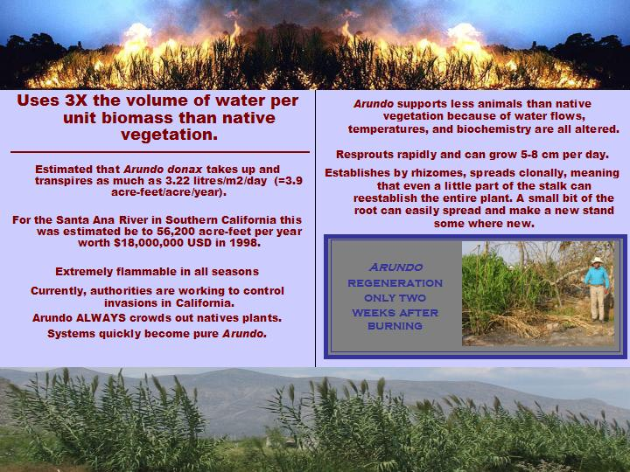
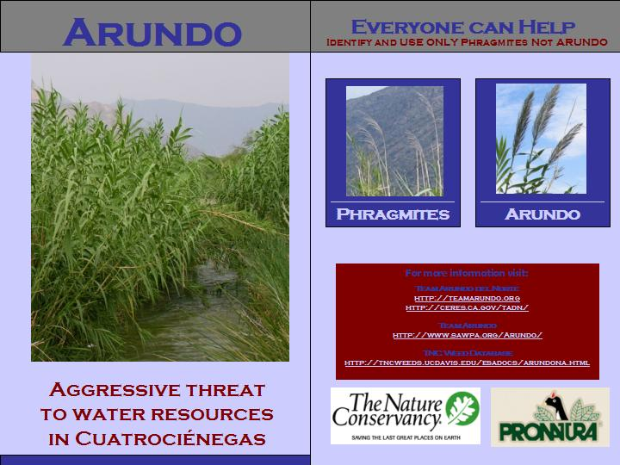
Community outreach

FrontBackInside
Fig 3. Arundo control brochure developed for outreach, needs translation to Spanish
Calegari (1997) noted that most Cuatro Ciénegas residents feel disconnected from research scientists who frequent the town, and the same message was voiced during the first Cuatro Ciénegas Researchers meeting. However, community involvement and education are imperative to conservation efforts (McDonald et al. 2004). Therefore, this
effort will include necessary education and serve as an invaluable medium to bridge the gap between the scientists and the local community, bringing them together in an attempt to control this invasive plant that obviously stands to affect all components of the local economy and ecosystem. The experimental procedure to test the safety of the application in the pozas will be performed not only by trained international scientist but also by a team of selected high school students that will participate at the field and at the lab in Mexico City.
Suggestions from the community at the Arundo workshop included development and dispersion of a brochure detailing the impacts of Arundo, explaining the severity of the threat to the water resources, and emphasizing that the native reed Phragmites is still a suitable construction material for fences, roofs, and palapas. This brochure has been developed (Fig 3.).

Expense & Timeline
Date | Action | Responsible Persons | Expense
July 1, 2005 | Management plan completed | Suzanne McGaugh | $0.00
July 1, 2005- October 1, 2005 | Compiling of aerial photography and targeting areas with infestation or in need or more mapping | Lucas McEachron | $0.00
October 1, 2005 | Herbicide Experiments Completed (covered by TNC grant) | Valeria Souza and Luis Eguiarte | $1560
October 1, 2005- November 1, 2005 | Approval of protocol by SEMARNAT/ CONANAP, and acquire any other (if any at all) necessary permission | ? This could be you!
July 1, 2005- November 1, 2005 | Investigation of cost, permitting procedures associated with aerial application in Rio Nadadores at Celemania.  1.5 gallons of Rodeo®/acre for ~15 acres
July 1, 2005- November 1, 2005 | Translation and dispersion of brochure to community members  (printing cost covered by TNC grant) | ? This could be you! | $500
July 1, 2005- November 1, 2005 | Acquisition of herbicide from Helena in Salinas, Coahuila | ? This could be you!
November 20, 2005 | First Application  1.5 gallons of Rodeo®/acre for 4 acres  Possible application of Reio Nadadores at Celemania | Dean Hendrickson,  Suzanne McGaugh,  SEMARNAT
January 1, 2006 | Written summary of treatment | Dean Hendrickson,  Suzanne McGaugh
September 2006-November 2006 | Continued monitoring. Follow-up, summary of treatment. | ? This could be you!
September 2007-November 2007 | Continued monitoring.  Follow-up, summary of treatment. | ? This could be you!
September 2008-November 2008 | Continued monitoring.  Follow-up, summary of treatment. | ? This could be you!
Total |  |  | $XXXX

Works Cited
Bell, G.P. 1993. Prado Basin resource management plan for the control of Giant Reed
(Arundo donax). The Nature Conservancy.

Bell, G.P. 199b. Santa Margarita management plan for the control of Giant Reed (Arundo
donax). The Nature Conservancy.

Bell, G. P. 1993c. Re-vegetation of riparian habitat: hauling coals to Newcastle? The
Nature Conservancy.

Bell, G. P. 1997. Ecology and management of Arundo donax and approaches to riparian
habitat restoration in southern California. Pg. 103-113 in J.H. Brock, M. Wade P.
Pysek, and D. Green, eds. Plant Invasion: Studies from North America and Europe. Leiden, The Netherlands: Backhuys.

Bell, G. P. 2005. Giant Reed (Arundo donax). Presentation at Arundo Control
Symposium, Cuatro Ciénegas, Coahuila, Mexico.

DellaCioppa, G., S.C. Bauer, B.K. Klein, D.M. Shah, R.T. Fraley, and G. Kishore. 1986.
Translocation of the precursor of 5-enolpyruvylshikimate-3-phosphate synthase
into chloroplasts of higher plants in vitro. Proc. Natl. Acad. Sci. USA.Vol. 83. 6873-6877

Dudley, T. L. 2000. Arundo donax L. Pg 53-58 in C.C. Bossard, J. M. Randall, and M.C. Hoshovsky, eds. Invasive Plants of California’s Wildlands. Berkeley, CA: University of California Press.

Environmental Protection Authority. 2001. Shark Bay World Heritage Property:
Environmental values cultural uses and potential petroleum industry impacts.
http://www.epa.wa.gov.au/docs/1642_SBWHP_Report01.pdf

Franz, J.E., M.K. Mao and J.A. Sikorski. 1997. Glyphosate: A Unique Global Herbicide.
American Chemical Society. Chap. 4 pp. 65-97

Henry, C. J. K. F. Higgins, and K. J. Buhl. 1994. Acute toxicity and hazard assessment of Rodeo®, X-77 Spreader®, and Chem-Trol® to aquatic invertebrates. Archives of Environmental Contamination and Toxicology (Historical Archive). 27: 392 - 399

Hutber G.N., L.J. Rogers, A.J. Smith. 1979. Influence of pesticides on the growth of cyanobacteria. Z Allg Mikrobiol. 19:397-402.

Khudamrongsawat, J., R. Tayyar, and J. S. Holt. 2004. Genetic diversity of giant reed (Arundo donax) in the Santa Ana River, California. Weed Science. 52: 395-405.

Laerke, P.E., 1995. Foliar Absorption of Some Glyphosate Formulation and their
Efficacy on Plants. Pesticide Science. Vol. 44. pp. 107-116

Li, S.N. and R.K. Kole. 2004. Response of gill ATPase and liver esterase of pseudorasobora parva to a two month exposure to glyphosate and metsulfuron methyl. Toxicological and Environmental Chemistry 86: 239 - 245

McDonald A., S.N. Lane, N.E. Haycock, E.A. Chalk. 2004. Rivers of dreams: on the gulf between theoretical and practical aspects of an upland river restoration. 29: 257-281.

Schuette, J. 1998. Environmental fate of glyphosate. Environmental Monitoring & Pest
Management. Department of Pesticide Regulation. Sacramento, CA 95824-5624

Secretaría de Desarrollo Social. 1994. Decreto por el que se declara como área protegida, con el carácter de protección de flora y fauna, la región conocida como Cuatro Ciénegas, municipio de Cuatro Ciénegas, Coahuila. Diario Oficial De La Federación, México CDXCIV(5):5-11

Shikha, Singh DP, Darmwal NS. 2004. Effect of glyphosate toxicity on growth, pigment and alkaline phosphatase activity in cyanobacterium Anabaena doliolum: a role of inorganic phosphate in glyphosate tolerance. Indian J Exp Biol 42: 208-13.

Stein, Bruce A., Lynn S. Kutner, Jonathan S. Adams, editors. 2000. Precious Heritage: The Status of Biodiversity in the United States. Oxford University Press, Oxford.

Wängberg SA and H. Blanck 1988. Multivariate patterns of algal sensitivity to chemicals
in relation to phylogeny. Ecotoxicol Environ Saf, 16(1): 72-82.

WSSA. 1983. Herbicide handbook of the Weed Science Society of America, 5th ed.
Champaign-Urbana, Illinois, Weed Science Society of America.

World Health Organization. 1994. International programme on chemical safety:
Environmental health criteria 159: Glyphosate. Published under the joint
sponsorship of the United Nations Environment Programme, the International
Labour Organisation, and the World Health Organization.
http://www.inchem.org/documents/ehc/ehc/ehc159.htm

